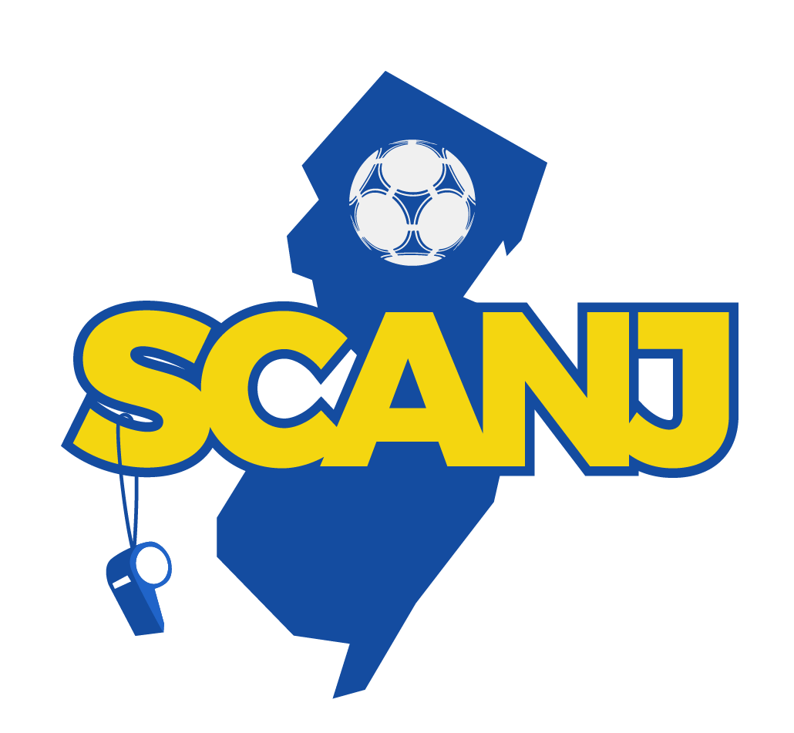

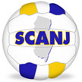
WAIVER OF CLAIMS AND HOLD HARMLESS AGREEMENT
SOCCER COACHES ASSOCIATION OF NEW JERSEY, INC.
Senior All Star Showcase Matches on December 9, 2023

This Waiver of Claims and Hold Harmless Agreement is hereby entered into on
______________, 2023 by and between the Soccer Coaches Association of New Jersey, Inc.,

and ________________________________________ (Name of Participant)

by ________________________________________ (Name of Guardian of Participant)

_______________________________________________ (Address of Participant and/or Guardian)

Whereas the Soccer Coaches Association of New Jersey, Inc. will be conducting Senior All Star Showcase Matches on December 9, 2023 at Capelli Sports Complex, Tinton Falls, N. J. and Participant has been invited to participate in such matches in accordance with the terms hereof; and Whereas participant acknowledges the Soccer Coaches Association of New Jersey, Inc. affords college recruiting opportunities through such matches, which represents good and valuable consideration for the waiver and hold harmless issued herein; Accordingly, participant for good and valuable consideration, hereby: 1. Waives any claims against the Soccer Coaches Association of New Jersey, Inc. and the Capelli Sports Complex, Tinton Falls, N. J. in connection with damages in the Senior All Star Showcase Matches on December 9, 2023; and 2. Agrees to indemnify and save harmless the Soccer Coaches Association of New Jersey, Inc. and Capelli Sports Complex, Tinton Falls, N. J. from any and all claims or damages arising out of or relating to participation in the Senior All Star Showcase Matches on December 9, 2023; and This Waiver of Claim and Hold Harmless Agreement is hereby executed and entered by and on behalf of the participant on the date noted below.

Participant___________________________________________ Print or Type Name Below

Signature Witness ___________________________________ Print or Type Name Below Signature

Guardian of Participant _______________________________ Print or Type Name Below

Signature Witness ___________________________________ Print or Type Name Below Signature

